Maze Game User Guide Document

By Rory Gallie

# 1. Introduction

This document will show how to use the maze game and the files you should have after downloading this game.

# 2. Files downloaded

After downloading the files from the website, unzip the zip file

And you will have the following folder:

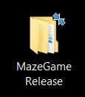

Within this folder will be another 2 folders, levels and maze.

Click the maze folder.

This will take you to another folder called “Version1.0”

Inside the “Version1.0” folder is the final folder “Maze Game Files”

Open this folder to find the following files for the maze:

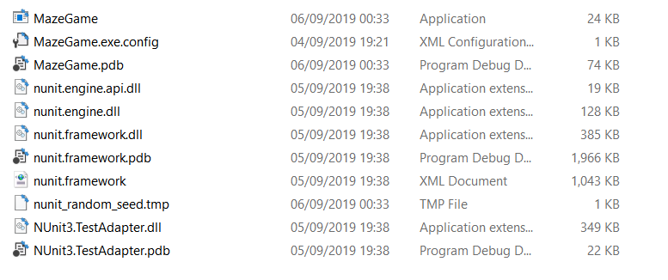

Click the maze Game application file to get started “MazeGame.exe”

# 3. Starting the game and playing

Once you have clicked the “MazeGame.exe”

A window will appear as shown:

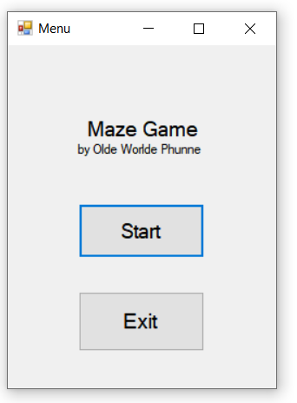

Click start to start the game and move on to the next screen:

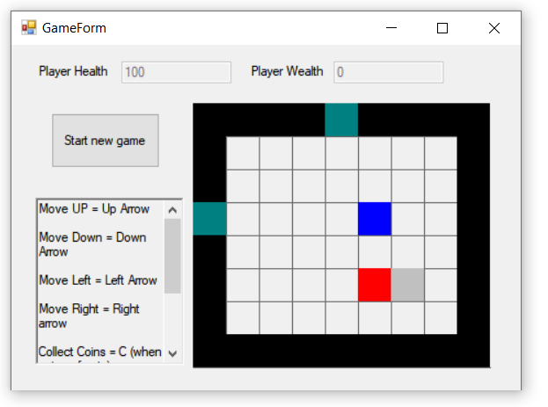

On the left hand side you will see the information about user inputs on how to play the game.

Follow these inputs for how to play.

If you would like to restart at any time click the start new game button.

Once you find a green square that is the exit.

The main objective of this game is to get as much wealth as possible.

Once you are finished with this game click the X in the window to exit the game.